1) Where do the Sinew Channels generally begin?
A) At the internal organs
B) At the extremities near fingers or toes +++++
C) At the neck
D) At the center of the abdomen
Feedback: Sinew Channels generally begin distally at finger or toe regions and ascend toward the trunk or head. Why are the other options incorrect? At the internal organs — Sinew Channels do not begin within the zangfu. At the neck — The neck may be a terminal or binding region but is not the general origin. At the center of the abdomen — The abdominal center is not the shared distal origin of the Sinew system.
2) Which feature distinguishes a Sinew Channel from a Divergent Channel?
A) A broad superficial musculotendinous route with joint bindings +++++
B) Deep entry into paired zangfu
C) Rejoining a paired Yang Primary Channel after convergence
D) An independent numbered point sequence
Feedback: Sinew Channels spread through superficial muscles and tendons and bind at joints without entering the zangfu. Why are the other options incorrect? Deep entry into paired zangfu — Deep paired-zangfu entry characterizes Divergent Channels. Rejoining a paired Yang Primary Channel after convergence — Convergence and rejoining a Yang Primary route characterize Divergent Channels. An independent numbered point sequence — Sinew Channels do not have independent numbered acupuncture-point sequences.
3) Which statement about zangfu penetration by Sinew Channels is correct?
A) All Sinew Channels enter their named zang organ.
B) Only Yang Sinew Channels enter zangfu.
C) Sinew Channels do not penetrate the zangfu. +++++
D) Only foot Sinew Channels enter zangfu.
Feedback: Sinew Channels are superficial musculotendinous pathways and do not penetrate the zangfu. Why are the other options incorrect? All Sinew Channels enter their named zang organ. — Entering the named zang organ is not a Sinew property. Only Yang Sinew Channels enter zangfu. — Yang Sinew Channels remain superficial as well. Only foot Sinew Channels enter zangfu. — Foot Sinew Channels also remain in the superficial musculotendinous system.
4) A broad pathway begins at the little toe and ascends the posterior leg and back with multiple binding regions. Which Sinew Channel is most likely?
A) Bladder Sinew Channel +++++
B) Stomach Sinew Channel
C) Spleen Sinew Channel
D) Liver Sinew Channel
Feedback: The Bladder Sinew Channel forms the broad posterior body chain from the little-toe region through the posterior leg and back. Why are the other options incorrect? Stomach Sinew Channel — The Stomach Sinew route is predominantly anterior. Spleen Sinew Channel — The Spleen Sinew route follows the medial lower limb. Liver Sinew Channel — The Liver Sinew route is medial and has a distinct genital-region relationship.
5) A broad pathway follows the anterior lower limb and anterior trunk. Which Sinew Channel should be considered first?
A) Stomach Sinew Channel +++++
B) Bladder Sinew Channel
C) Gall Bladder Sinew Channel
D) Kidney Sinew Channel
Feedback: The Stomach Sinew Channel is recognized as a broad anterior Foot Yang body chain. Why are the other options incorrect? Bladder Sinew Channel — The Bladder Sinew route is primarily posterior. Gall Bladder Sinew Channel — The Gall Bladder Sinew route is lateral. Kidney Sinew Channel — The Kidney Sinew route follows the medial Foot Yin territory.
6) Which route best characterizes the Gall Bladder Sinew Channel?
A) A lateral body chain from the foot toward the side of the trunk and head +++++
B) A medial route from the great toe into the abdomen
C) A posterior midline route beginning at the coccyx
D) A chest-to-thumb route
Feedback: The Gall Bladder Sinew Channel follows a characteristic lateral Foot Yang distribution toward the lateral trunk and head. Why are the other options incorrect? A medial route from the great toe into the abdomen — A medial great-toe route is more consistent with a Foot Yin Sinew Channel. A posterior midline route beginning at the coccyx — A posterior midline route is not the ordinary Gall Bladder Sinew course. A chest-to-thumb route — Chest to thumb describes the Lung Primary direction and territory.
7) Which Sinew Channel begins near the index finger and follows the lateral arm toward the shoulder, jaw and nose region?
A) Large Intestine Sinew Channel +++++
B) Small Intestine Sinew Channel
C) Lung Sinew Channel
D) Pericardium Sinew Channel
Feedback: The Large Intestine Sinew Channel follows the anterior Hand Yang territory from the index finger toward the shoulder and face. Why are the other options incorrect? Small Intestine Sinew Channel — The Small Intestine Sinew route begins near the little finger and follows the posterior arm and scapula. Lung Sinew Channel — The Lung Sinew route is a Hand Yin course related to the thumb and anterior-medial arm. Pericardium Sinew Channel — The Pericardium Sinew route occupies the middle Hand Yin territory.
8) Which landmarks best fit the Small Intestine Sinew Channel?
A) Little finger, posterior arm, scapula and ear/eye region +++++
B) Index finger, anterior-lateral arm and nose
C) Thumb, thenar region and chest
D) Middle finger, central palm and anterior chest
Feedback: The Small Intestine Sinew Channel is recognized by its little-finger origin and posterior arm, scapular and face distribution. Why are the other options incorrect? Index finger, anterior-lateral arm and nose — Index finger and nose better fit the Large Intestine family. Thumb, thenar region and chest — Thumb and chest better fit the Lung family. Middle finger, central palm and anterior chest — Middle finger and central anterior course better fit the Pericardium family.
9) What is the channel shown in the image?
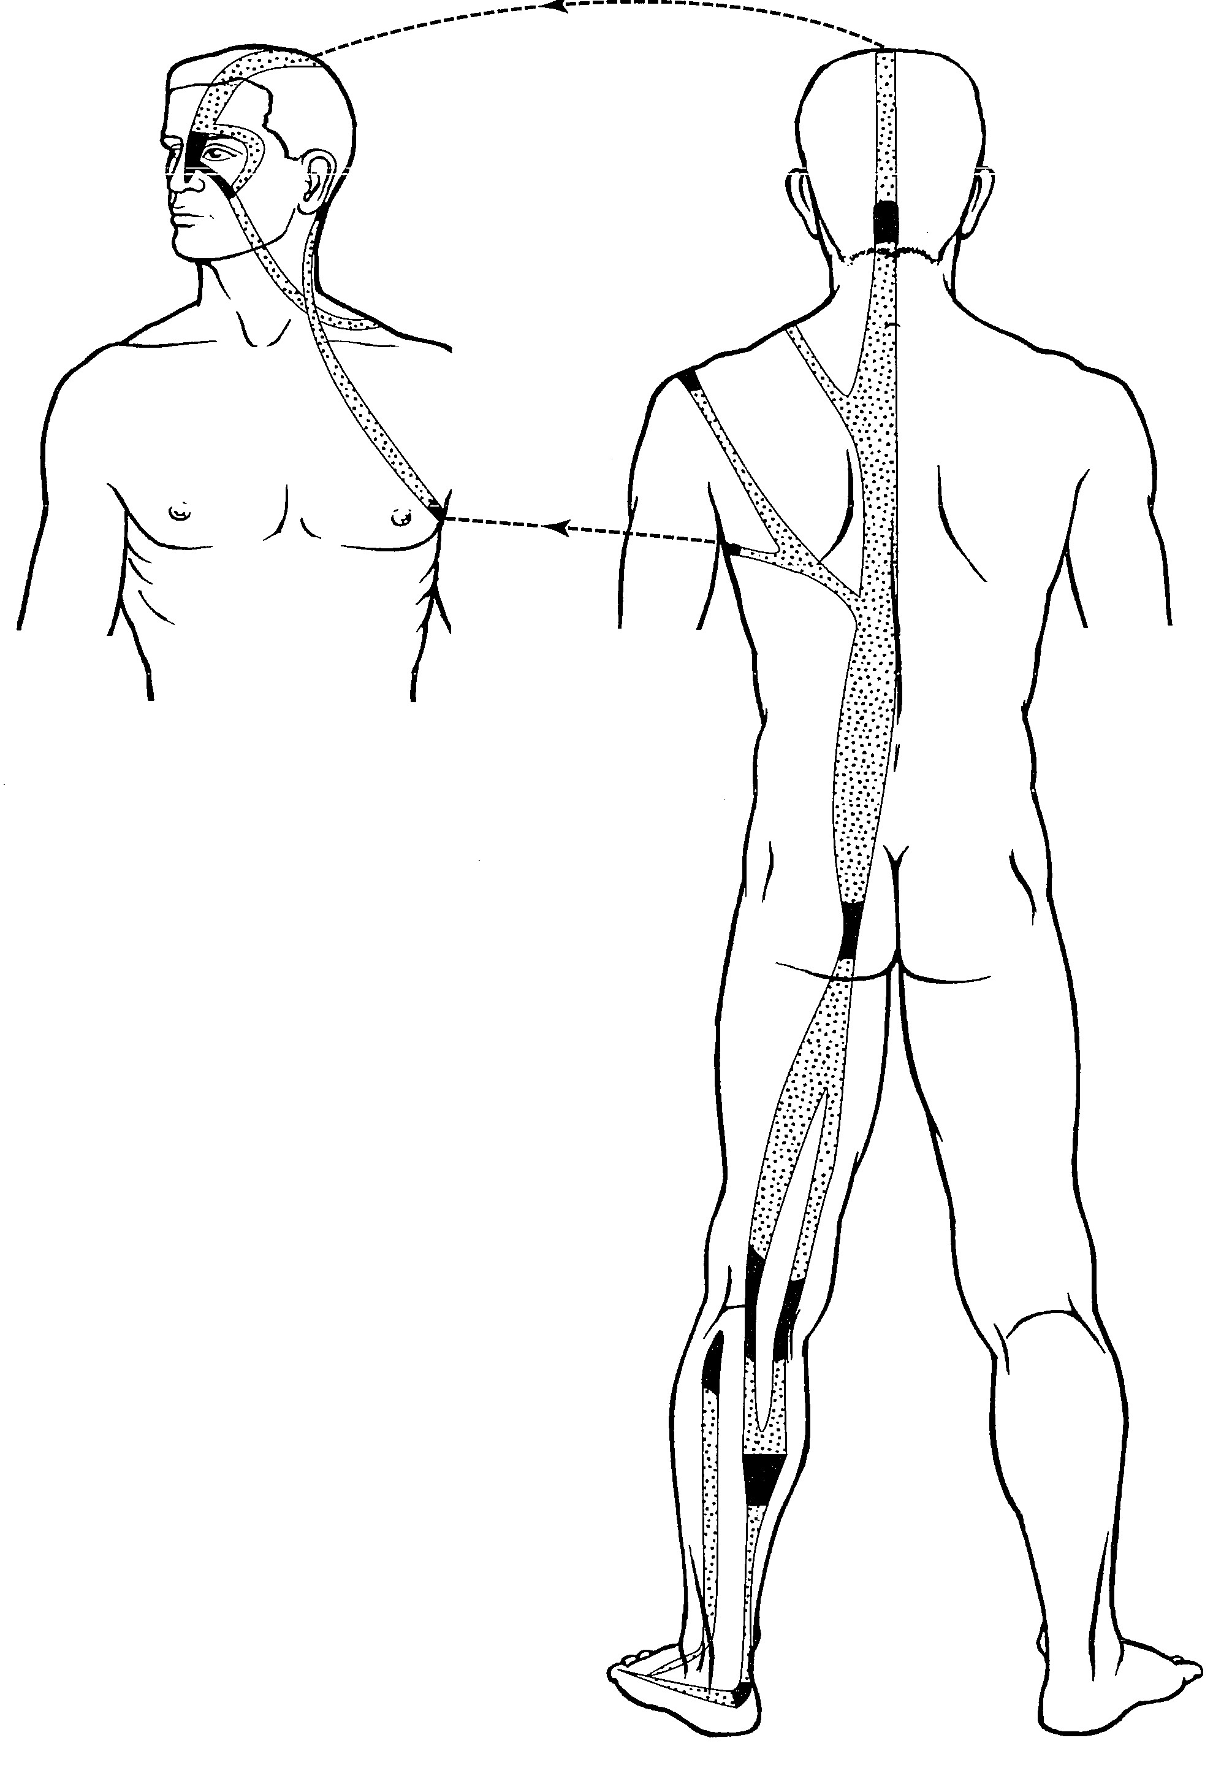
A) Bladder Sinew Channel +++++
B) Bladder Divergent Channel
C) Bladder Luo-Connecting Channel
D) Bladder Primary Channel
Feedback: The Bladder Sinew Channel is identified by its broad superficial posterior chain from the little toe and heel through the calf, popliteal region, thigh and paraspinal muscles to the neck and head, with multiple binding regions and a facial branch. It has no internal zangfu connection. Why are the other options incorrect? Bladder Divergent Channel — The Divergent Channel follows a deep internal route related to Kidney and Bladder. Bladder Luo-Connecting Channel — The Luo-Connecting Channel begins at BL-58 and forms a limited connecting branch. Bladder Primary Channel — The Primary Channel is the narrower point-bearing posterior reference pathway.
10) What is the channel shown in the image?
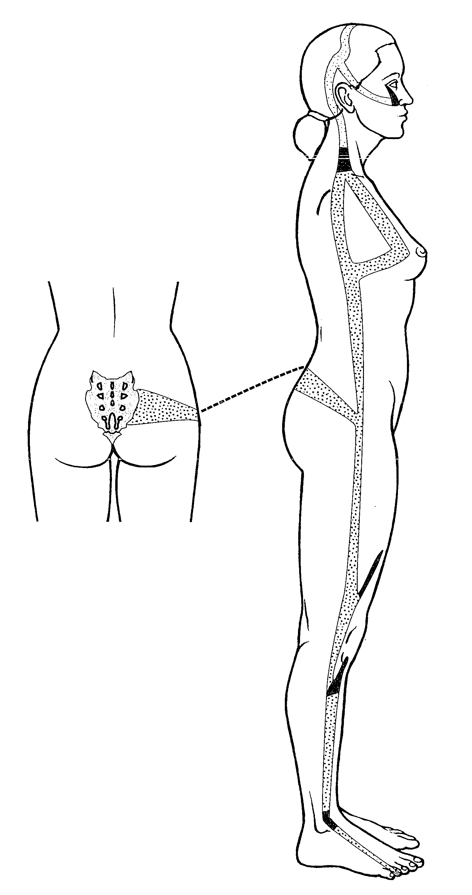
A) Gall Bladder Sinew Channel +++++
B) Gall Bladder Divergent Channel
C) Gall Bladder Luo-Connecting Channel
D) Gall Bladder Primary Channel
Feedback: The Gall Bladder Sinew Channel follows a broad superficial lateral route from the fourth toe through the lateral ankle, knee, thigh and hip, with branches to the sacral region, flank, chest, axilla and lateral head. Its muscular and joint bindings identify a Sinew pathway rather than an internal channel. Why are the other options incorrect? Gall Bladder Divergent Channel — The Divergent Channel has a deep internal convergence with the paired Liver pathway. Gall Bladder Luo-Connecting Channel — The Luo-Connecting Channel begins at GB-37 and follows a short connecting route. Gall Bladder Primary Channel — The Primary Channel is the complete point-bearing lateral route.

